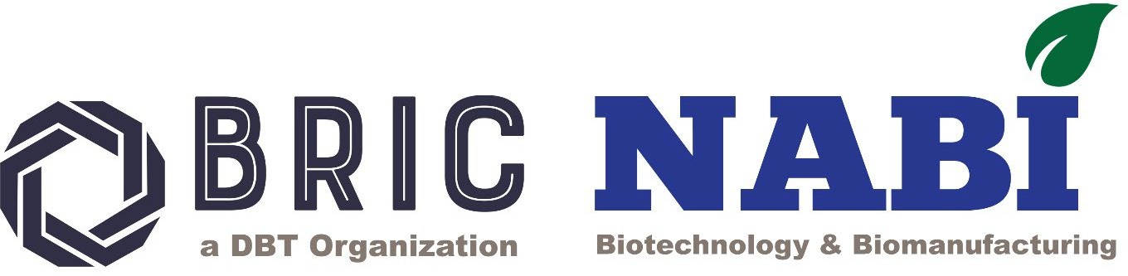

NATIONAL AGRI-FOOD AND BIOMANUFACTURING INSTITUTE (BRIC-NABI)
(De pt. of Biotechnology, Ministry of Scie nce & Technology, Govt. of India) Knowle dge City, Sector 81, S.A.S. Nagar, Mohali 140306, Punjab, INDIA Website: www.nabi.res.in
Under the umbrella of
National Genome Editing and Training Centre (NGTEC)
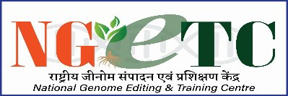
Invites Application For Workshop
on
"Genome editing: Tools, experimental design and its applications"
(NGETC NABI--Series-VII)
Application Form

Name of the candidate (In caps)
Date of birth
Gender
Current Designation
Current Affiliation
Official Address and Contact number with email:
Educational qualification: (Starting from Bachelor’s Degree onwards)
Ongoing area/s of research
(<50 words)

Representative research Publications
(if any; not more than five)
Details of previously attended genome editing/functional genomics workshop (if applicable)
Why you wish to attend the genome engineering workshop?
Letter of forwarding/support from the Head of your current
institute/department/college etc. (As separate Annexure 1)

Date
Place Signature of the candidate

Instruction:
- Candidates are requested to fill in the information above properly.
- Candidates should attach the “Letter of forwarding/support from the Head of your current institute/department/college etc.” and merge the same with the application form as a pdf format and send the same at ngetcnabi@gmail.com on or before 30th May
,2025.
- Limited seats (16) are available for the above workshop.

*Last date of Application submission 30 October 2025*

