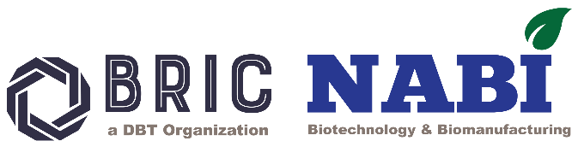

BRIC National Agri-Food and Biomanufacturing Institute (BRIC NABI)

Hands-on-Training on “Dynamic Mechanical Analyzer (DMA)”

6-8 OCTOBER 2025

Subject: Hands-on-Training on Dynamic Mechanical Analyzer (DMA)
Schedule: 3 Days (6-8 October 2025) from 9.00 am to 5.30 pm.
Registration Deadline: 28 September 2025
Proposed Program: This training program provides comprehensive hands-on experience with the Dynamic Mechanical Analyzer (DMA). This technique is widely used to characterize the viscoelastic properties of materials, particularly polymers, by applying a cyclic force and measuring the resulting deformation. DMA is employed in various industries for research, quality control, pharmaceuticals, food industry, product development etc.
This course is designed to equip participants with in-depth knowledge of the principles, hardware, and software of DMA systems. Attendees will gain practical expertise in operating the equipment, the use of its different accessories, and interpreting analytical data. Through this training, users will develop the skills necessary to apply DMA techniques effectively in research and industrial applications.
Brief Details of Central Instrumentation Facility: Central Instrumentation Facility (CIF) at NABI, Mohali, has been extending its services to researchers for 12 years, and it was established by the Department of Biotechnology (DBT), Ministry of Science and Technology in 2012. This facility helps develop the analytical skills of scientists, research personnel, and students engaged in R&D activities. CIF also offers training programs on science and technology advancements to wide users across India and is offering time to time training in advance equipment’s. CIF facility is also available to outside professionals for sample testing at very nominal rates.

Scope of Training: This training program on Dynamic Mechanical Analyzer includes:
- Fundamental Knowledge: Understanding the principles of DMA, role of its various accessories used during analysis
- Experimental Design: Developing well-structured experiments that prioritizes data accuracy and reliability.
- Sample Handling: Mastering proper sample preparation, selection of appropriate accessories, and effective utilization of software for process control and data analysis.
- Data Analysis and Troubleshooting: Interpreting measurement results effectively and identifying and resolving any experimental challenges
- Hands-on Training: Practical operation of DMA with use of different accessories to perform dynamic mechanical analysis.
- Practical Experience: Engaging in laboratory sessions and interactive discussions.

Brief note on the technique:

Dynamic Mechanical Analyzer (DMA) precisely quantifies the viscoelastic properties of a material as a function of temperature, time, frequency and amplitude. DMA is mainly used to determine the material’s modulus and stiffness, but also its damping properties, creep and relaxation. This provides crucial insights into glass transition temperatures and further characteristic transitions, the effect of fillers and additives, compatibility of polymers, and much more.

Fee details: ₹ 2,500/+18% GST
Note:
  - The training fee excludes the accommodation charges. Limited seats are available in Guest House which can be provided at nominal rates to participants on first come first serve basis.
  - The training Program includes provision of morning and evening tea along with lunch to all the participants of the Program.

Criteria and Eligibility of Training Program: The details are as follows:
- Educational Qualification: BSc/B.Tech/MSc/M.Tech/PhD degree holders and pursuing candidates may participate in the training program.
- Since seats are limited, the selection criteria of the participants will be purely on First come, First Service Basis with the fulfilment of the above eligibility conditions.

General Conditions:
  - Interested candidates must fill out the registration form latest by 28th September 2025 and send a request to Email ID: sandhya.yd@ciab.res.in (Sandhya Yadav – 0172-5221-515).

  - The Google link for the form is as follows:
https://forms.gle/3kyd25MAkZvmEX4Y7

  - In addition, the STUDENT RESEARCH SCHOLARS may need to submit the NO OBJECTION CERTIFICATE and DECLARATION (formats available in the same document at the end) by 03-10-2025 via email.
  - All candidates whose candidature is accepted by the competent authority for the training program shall be informed by 30-09-2025. Post confirmation of candidature acceptance from NABI, Mohali, Candidates must deposit the fees and share proof of payment with sandhya.yd@ciab.res.in by 02-10-2025, 5.00 PM. Late payments or confirmation will lead to cancellation of candidature and no separate intimation will be sent in this regard.
  - Training will be held from 06-10-2025 to 08-10-2025.
  - Fees once paid, will not be returned even if the candidate wishes to withdraw his/her application for the training program.
  - BRIC NABI also provides guest house accommodation on a paid basis at ₹ 1,000/- per day (Taxes and food charges extra), however, subject to the availability of rooms.
  - All participants during their presence in the campus must adhere to the conduct & discipline rules applicable inside the campus.

Payment details: By online payment as per bank details provided below:

Beneficiary Name: National Agri-Food Biotechnology Institute
A/c No: 31791059995
Bank Name: State Bank of India
Branch Code: 1828
IFSC Code: SBIN0001828
MICR Code: 160002023
GST No. in r/o NABI is 03AABAN0279L1ZM

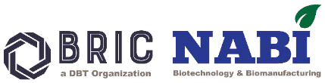
BRIC National Agri-Food and Biomanufacturing Institute (BRIC NABI)

NO OBJECTION CERTIFICATE

The applicant Prof. /Dr. /Mr. /Ms.
from our institution will be permitted to attend the “Hands-on Training on Dynamic Mechanical Analyzer” to be held from 06-10-2025 to 08-10-2025 at the BRIC National Agri-Food and Biomanufacturing Institute (BRIC NABI), if selected for the same.

Place: Signature
Date:

(Head of the Institution with seal)

DECLARATION BY THE CANDIDATE

I agree to abide by the rules of the BRIC National Agri-Food and Biomanufacturing Institute (BRIC NABI), Mohali. If selected, I shall participate in the course for the entire duration.

Date:
Place: Signature by the Candidate

(Scanned copy should be submitted in advance through email to sandhya.yd@ciab.res.in)
How to Reach BRIC NABI:

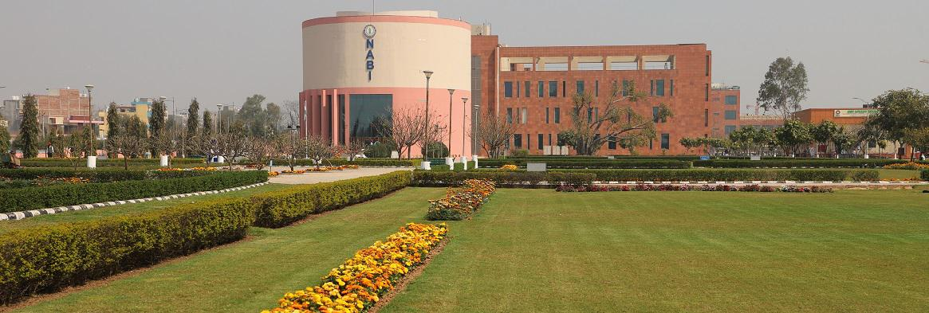
https://maps.app.goo.gl/WowQSbhdSEmPdh1y6

BRIC National Agri-Food and Biomanufacturing Institute
Sector-81 (Knowledge City), PO Manauli, S.A.S. Nagar,
Sahibzada Ajit Singh Nagar (Mohali), Punjab 140306

Campus Tour: https://www.youtube.com/watch?v=FakjOcrcKOw

 | https://www.facebook.com/BRICNABI/
 | https://www.youtube.com/@DBT-NABI

